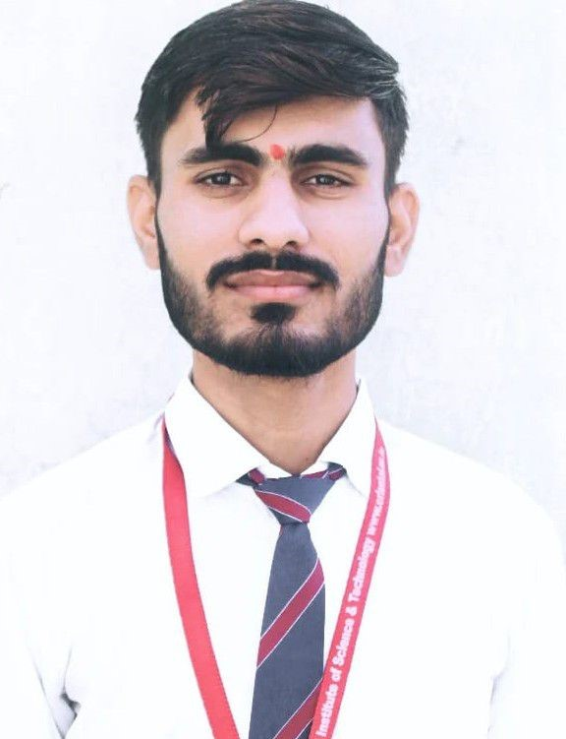**GANESH PRASAD TIWARI**

Anand nagar raisen road bhopal mp

gt167477@gmail.com | +917415028331

**in** https://www.linkedin.com/in/ganesh-tiwari-173215207

# OBJECTIVE

As a fresher looking for an organization where I can enhance my knowledge and technical skills from my academic learning. I would like to give my best to work with a highly esteemed company which give me a platform to use my experiences and skills for mutual growth and benefit of company and myself.

# EDUCATION

* **ORIENTAL INSTITUTE OF OF SCIENCE AND TECHNOLOGY BHOPAL**  **2023**

MCA

**86**

* **PENTIUM POINT TECHNICAL COLLEGE REWA**  **2021**

BCA

**72.98**

* **GOVT H S BOYS SCHOOL MANGAWAN** **2017**

12th

58.06

* **GOVT H S SCHOOL SURSA REWA**  **2015**

10th

**52.67**

# SKILLS

* HTML5
* CSS3
* Bootstrap
* JavaScript
* C Basic
* Python Basic
* MySQL
* computer network

# PROJECTS

* **online job portal**

The objective of this project is to develop an online portal where recruiters can post job requirements, they can search for candidates. Candidates can search for job openings and apply.

* **Employee management system**

Employee Management System Python project assists in the automation of manual operations, saving both time and money. This system protects the professional and personal information of employees and the company.

# INTERESTS

* Playing cricket
* Traveling
* Watching movies
* Playing kabaddi

# ACHIEVEMENTS & AWARDS

* plantation
* food festival
* poster making

# CERTIFICATION

* **python for beginners from great learning:**

<https://olympus1.mygreatlearning.com/course_certificate/OZYWGSTJ>

* **HTML from great learning academy:**

<https://olympus1.mygreatlearning.com/course_certificate/QTONEYGO>

* **cyber security from cisco:**

<https://www.netacad.com/portal/profile/1037436751/certific>

# personal details

Father name**:** Kailash prasad Tiwari

Date of birth**:** 12/05/1999

Religion: Hindu

Nationality: Indian

Language: Hindi, basic English

Marital status: single

# STRENGTH

* Strong decision maker
* Complex problem solver
* Ability to rapidly build relationship and set up trust.

# DECLARATION

* All the information which was given by me is correct.

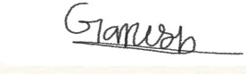

**Signature**:  
 Ganesh prasad tiwari

